

|  |  |
| --- | --- |
| **Name: Sayyed Sohail Rashid** | **Course Name: SMA-LAB** |
| **Class: BE-CO** | **Batch: 01** |
| **Roll no: 18CO48** | **Experiment No: 02** |

**Aim:** Data Collection-Select the social media platforms of your choice(Twitter, Facebook, LinkedIn, YouTube, Web blogs etc) ,connect to and capture social media data for business (scraping, crawling, parsing).

# Theory:

**Social Media Scraping of Apple using Python:**

**1. Instagram:**

1. from instagramy import InstagramUser
2. import pandas as pd 4.
3. user = InstagramUser("Apple")
4. print(f"Username: {user.fullname}")
5. print(f"Biography: {user.biography}")
6. print(f"Verified User: {user.is_verified}")
7. print(f"Website: {user.website}")
8. print(f"Followers: {user.number_of_followers}")
9. print(f"Following: {user.number_of_followings}")
10. print(f"No. Of Posts: {user.number_of_posts}") 13.

14.posts = user.posts

15.instaPosts = []

1. for i in range(10):
2. post = {}
3. post["Post"] = i+1
4. post["Likes"] = posts[i].likes
5. post["Comments"] = posts[i].comments

21.

22.

post["Caption"] = posts[i].caption

instaPosts.append(post)

23.print(f"Latest posts:\n {pd.DataFrame(instaPosts)}")

24.

**Output**

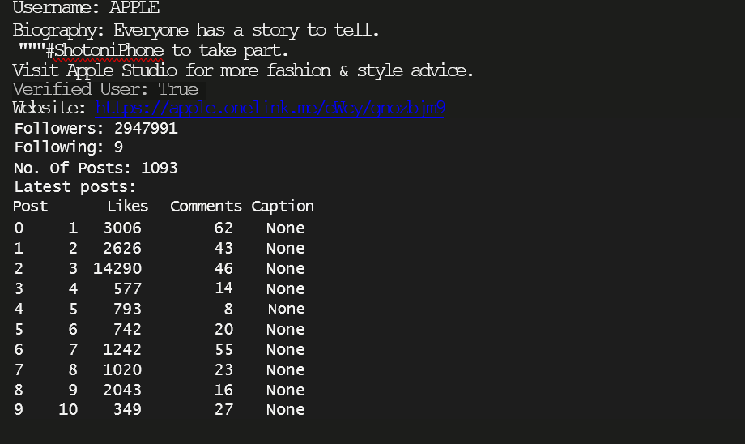

1. **Facebook:**
2. # Facebook
3. from facebook_scraper import get_posts 27.

28.fbPosts = []

1. for post in get_posts('Apple', pages=10):
2. fbPosts.append({x: post[x] for x in ['post_id', 'text', 'likes']})
3. print(print(f"Latest posts:\n {pd.DataFrame(fbPosts)}"))

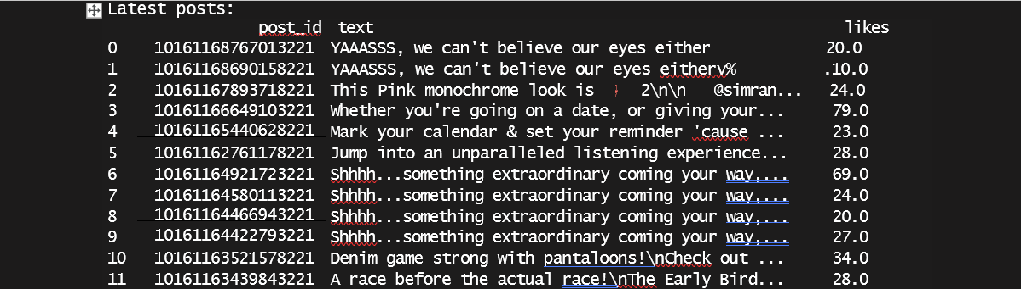

1. **Twitter:**

from twitter_scraper_selenium import get_profile_details twitter_username = "Apple"

filename = "twitter_api_data"

get_profile_details(twitter_username=twitter_username, filename=filename) import json

with open('twitter_api_data.json', 'r') as json_file: json_object = json.load(json_file)

print(json.dumps(json_object, indent=1))

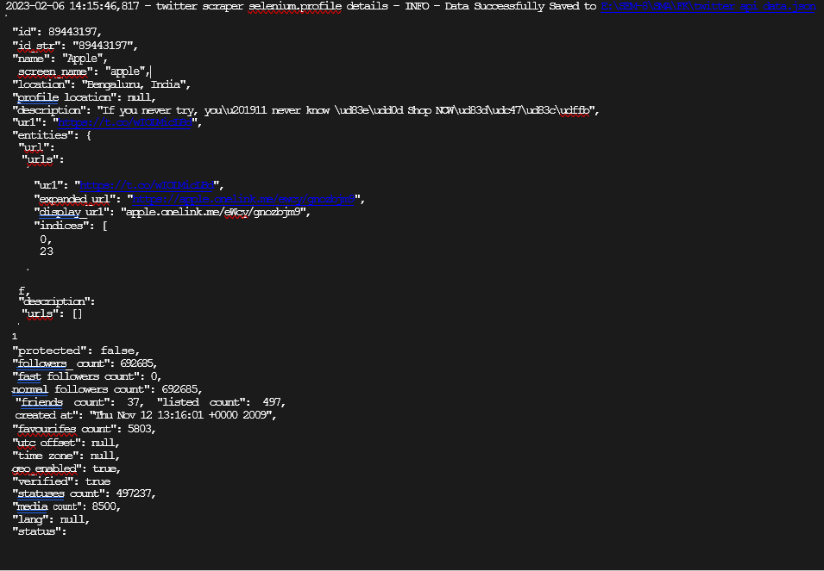

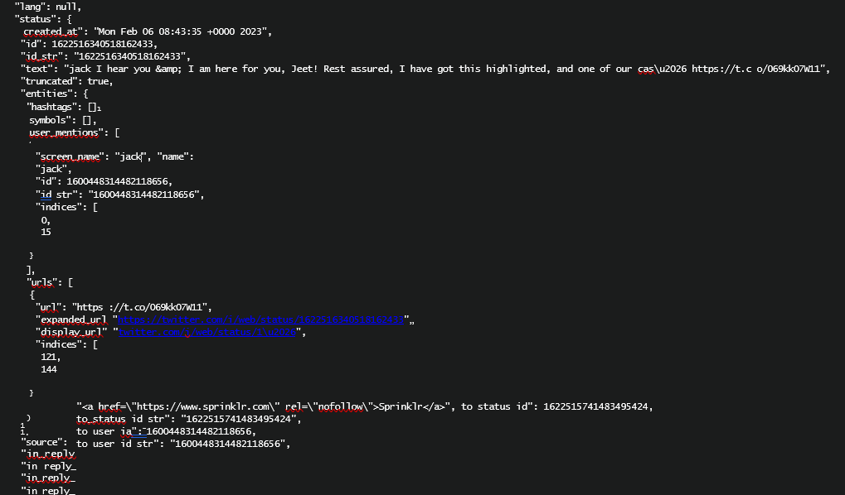

**Conclusion:**

The data collection has been done for Apple from multiple websites such as Twitter, Facebook, Instagram. In order to connect and capture social media data for businesses (scraping, crawling, parsing).